Assignment 8:
- Create student/Employe Databade Table for 7 fields with data type as int,char,string,numc.
- Created database table with name ZKR_STUDENT
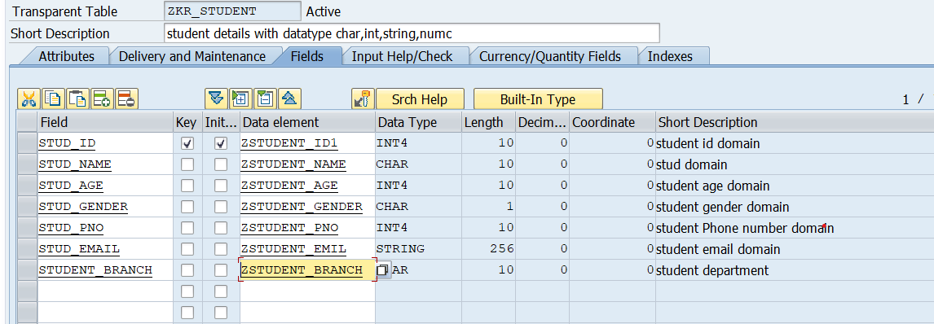

- Table Entries:->
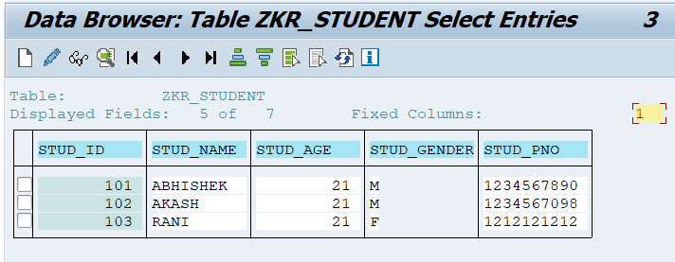

- Can we create Database Table without Domain? & How?
- Yes we can create Database table without Domain.

- Select the Data type radio button on the pop-up.
- Enter a short description
- On the Data Type tab, select the Built-in type radio button.
- Enter the built-in ABAP Dictionary data type, length, and decimal places directly
- Go to the Field Label tab and maintain the field labels (short, medium, long, heading).
- Save and activate the data element.
- Now, create database table (ZDOMAIN_DEMO), but for the fields, enter the name of the Data Element (ZDE_DEMO) we just created.
- 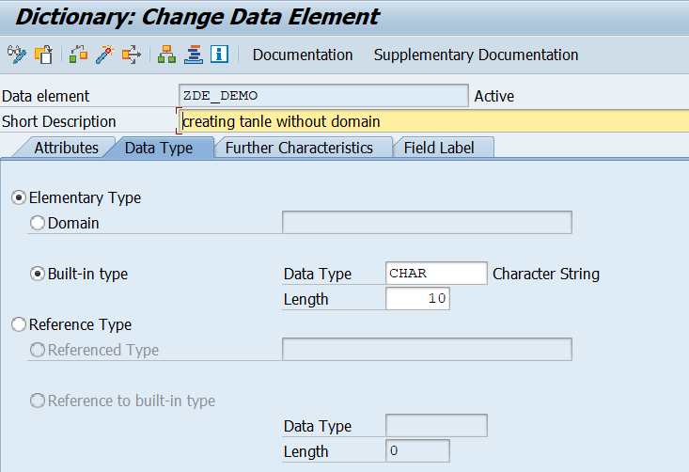

- Can we create Database Table without Data Element? & How?
- Yes, we can create a database table without creating a Data Element
- Enter the required table name (ZDATAELEMENT_DEM) and click on Create.
- provide a short description, select the delivery class, and choose Display/Maintenance Allowed, then continue.
- Now open the Fields tab.
- Enter the field name and mark the Key checkbox if the field is a primary key.
- Leave the Data Element column empty.
- Click on the Built-In Type button available at the top of the Fields tab.
- A popup window will appear showing different ABAP data types.
- Select the required built-in data type such as CHAR, NUMC, INT4.
- enter the required length.
- After defining all fields, save the table and click Activate.
- And The database table will be created successfully without using a data element.
- 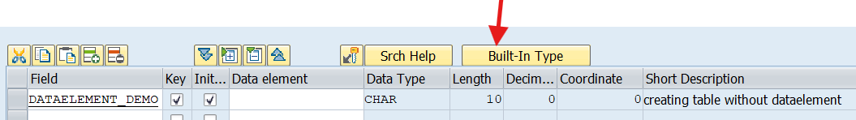

- What will happen to earlier data & updated data when we change Data length from 10 to 5?
- When we change the Data length from 10 to 5
- Activation will be partial or failed
- Error message is displayed
- SAP protects data and does not automatically delete or cut existing values.
- Reducing the data length from 10 to 5 table will truncate(cut) existing data exceeding the new length and limit any future entries accordingly.
- Data Loss: The truncation leads to potential permanent loss of original data
- 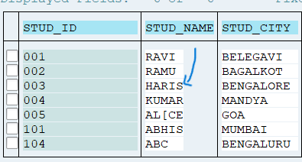
- (Here HARISH H is deleted).

- What are the properties of Data Element?
- A data element defines the semantic meaning (business meaning) of a field and links it to a domain.
- Data Type: The type of data (e.g., CHAR, NUMC, DATS, INT4).
- Length: The length or number of positions the field can hold.
- Decimal Places: Specifically for numeric types like QUAN or CURR.
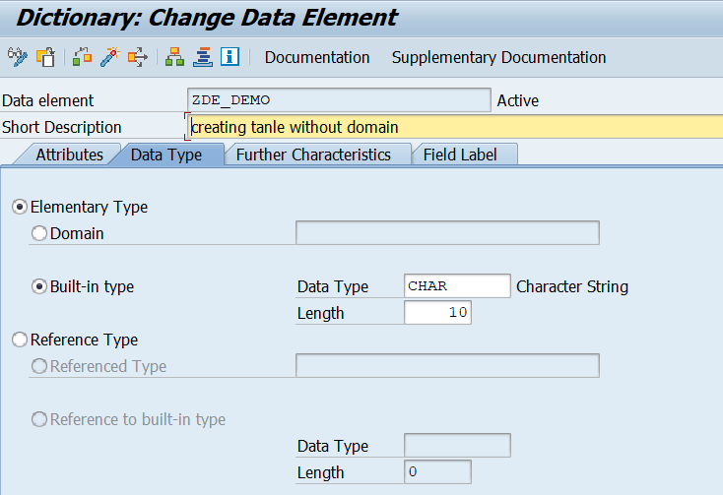

- Field Label:
Short Label (10 chars): Used for narrow columns or small UI elements.
Medium Label (20 chars): A standard length for most labels.
Long Label (40 chars): Used when the full description is necessary.
Heading (55 chars): Often used as the column header in ALV reports or tables.
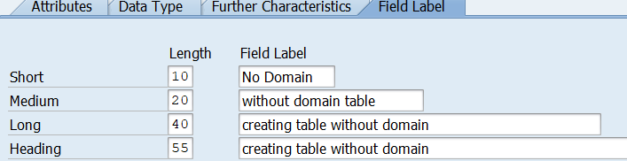

- Search Help: You can attach a search help (F4 help) directly to a data element so that every field using it automatically gets a dropdown/selection list.
- Documentation: You can write "F1 Help" text for the data element, which explains to the user what they should enter in that field.
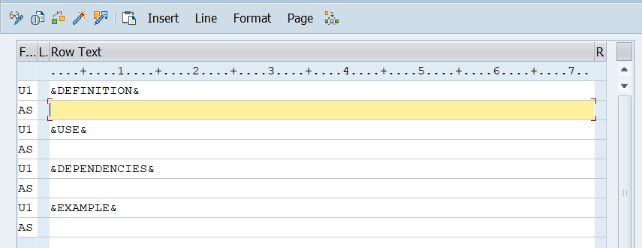
- Parameter ID (SPA/GPA): Allows the system to "remember" a value (like a User ID or Company Code) across different screens and sessions.

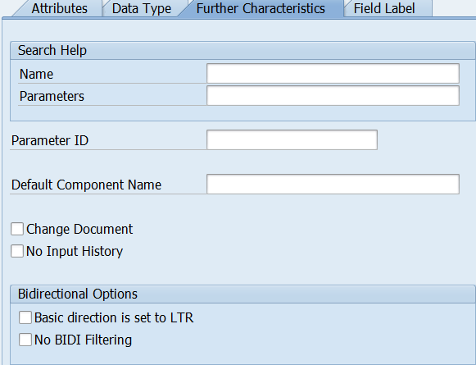
- Sign & case-sensitive when we use & what it does when we select or deselect.
- 1. The "Sign" Checkbox
This property is used for numeric data types (like DEC, QUAN, CURR, or FLTP). It determines whether the field can store negative numbers.
When to use: Use this when a value can logically be less than zero—for example, temperature, account balances, or profit/loss figures.

- When Selected:
The field can store both positive and negative values.
The output length of the field is increased by one character to accommodate the minus sign (usually displayed at the end of the number in SAP, e.g., 100.00-).

- When Deselected:
The field can only store positive values (absolute values).
If a program tries to pass a negative value to this field, the system may truncate the sign or cause a short dump depending on the context.

- 2. The "Lower Case" Checkbox
This property is used for character-based data types (like CHAR or STRG). By default, SAP converts all text input to uppercase.
When to use: Use this for fields where the exact casing matters, such as email addresses, passwords, URLs, or long descriptive text.

- When Selected:
The system preserves the casing exactly as the user enters it (e.g., "Apple" stays "Apple").
This makes the field case-sensitive during database searches. A search for "APPLE" will not find "Apple."

- When Deselected:
The system automatically converts all input to UPPERCASE (e.g., "apple" becomes "APPLE") before saving it to the database.
This is the standard for most SAP codes (like Material Numbers or Plant Codes) to ensure consistency and easier searching.

- What is value Range & it's use?
- A Value Range is a predefined set of allowed values that can be entered into a field in SAP.
- It restricts the user from entering invalid data by allowing only specific values for that field.

- Value Range is used to:
Ensure data accuracy
Prevent invalid inputs
Maintain data consistency across tables
Provide F4 (Input Help) for users

- Example
For a Gender field, instead of allowing any text, we define a value range
- Advantages of Value Range
Improves data quality
Avoids manual validation
Standardizes data across the system
Enables dropdown (F4 help)

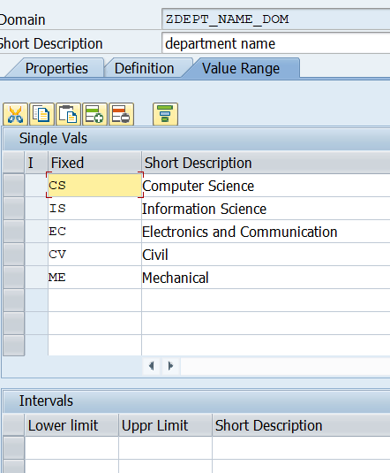

- What is Data class? (APPL0,APPL1,APPL2)
- A Data Class defines how and where table data is physically stored in the database.
- It tells SAP whether the table contains master data, transaction data, or organizational/customizing data.
- Data class helps the database optimize performance by storing different types of data in suitable areas.
- Why is Data Class important?
It improves database performance, ensures efficient data storage, and helps the system manage data growth properly.

- (A Data Class in SAP specifies the type of data stored in a table and controls how the data is physically stored in the database.)
- 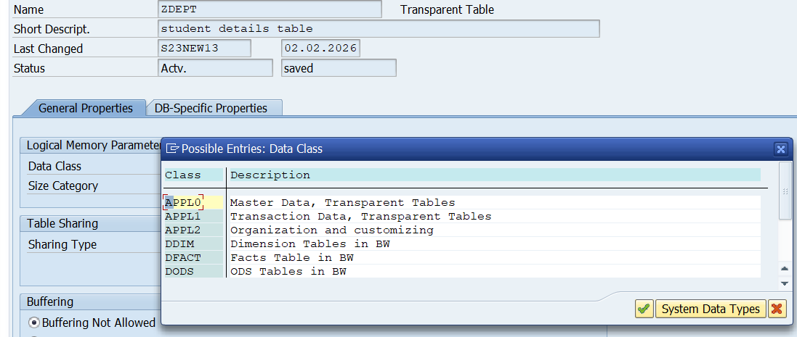

- What is size category?
- Size Category defines the expected number of records that a database table will store.
It helps SAP decide how much database space to allocate for the table.

- Size Category is used to:
Optimize database performance
Allocate proper storage space
Avoid frequent table reorganization

